**SE DESINO**

**Table of Contents**

SE DESINO

Introduction 3

Installation and application setup 3

Launching the Program 3

Login page 4

Main Menu Page 5

Modules 6

Select levels in modules page 7

Level Description Page 8

Puzzle page 9

Questionnaire page 10

Round over page 11

**Introduction**

SE Desino is the fast and friendly application in collecting, storing and retrieving the user file electronically. Its focus is to store and extract data easily when required, keep track of user progress and manage user file.

The SE Desino was designed to be an interactive and user-friendly application; therefore, most features will make sense to its users. However, all features are also explained in detail in the help sections.

The game consists of data of the three topics namely UML, cohesion and coupling, design patterns. Then the user or client can study those topics and can easily solve the questions that are given. The score is related at the last with some comment. That would be helpful for the better improvement the next time. If the level is completed, the user can go to the next level. The user or client can quit the game at any time if required.

The SE Desino application is developed as a stand-alone application. These login windows will appear as soon as the program runs. This SE Desino’s main control, login window, will provide different controls to interact with the application, allowing the selection for different tasks.

**Installation and application setup:**

The information of installing the application setting up the environment of the computer to establish database connection.

This system is a stand-alone application, so there is a simple installation procedure. It is done and tested on windows operating systems. It contains inbuilt database, so there is no need to download any database server or application. The system is developed in unity and hence is platform independent.

**Launching the application**

To launch this program, you need username and password to login to the software.

When application starts, first page would be a login page. Only the authorized users will be allowed to login into system. The user can enter, update, delete, or retrieve any data related to student and their application after successful login.

After successful login, the home page will be displayed, which is the common interaction screen from which user can make selection among specified options. From every selected page, there is a link which can lead user back to home page, from which user can select different options also. When you are done with the application, you can simply click exit on every page to come out of screen. Also, there is an option for logout, by clicking that button current session will be ended.

**Login Page**

The below screen shows the user/client to login to the application when they are registered. If the client/user is not registered can click on option to create account at the registration side. The power button exits from the application. After the user registers the account they get the message as “Registration Successful”. If the user name already exists, it gives the same message as “ User already exists”.

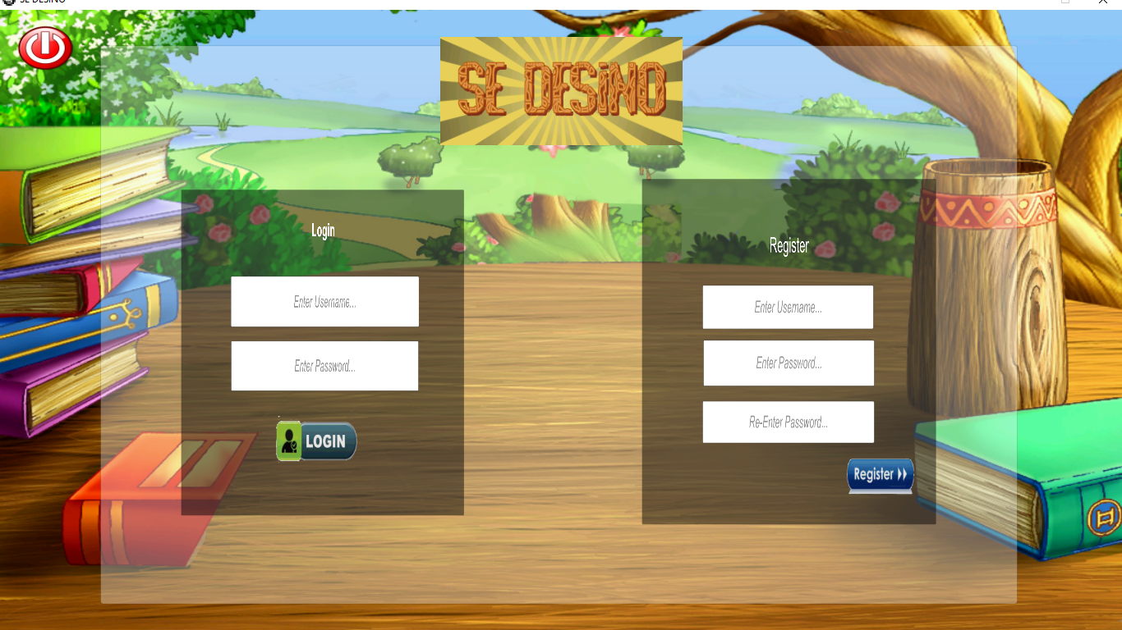

**Main Menu page**

The below is the main menu page after the client/user is logged in and can choose the options if required. The user/ client can play the game. It has the save option, it helps the user to save the game at any moment of time. Quick Test helps in playing the test. Logout helps the user to logout from the account and that goes back to login page. In this main menu page, the user can choose the option of sound value and can mute the sound if needed.

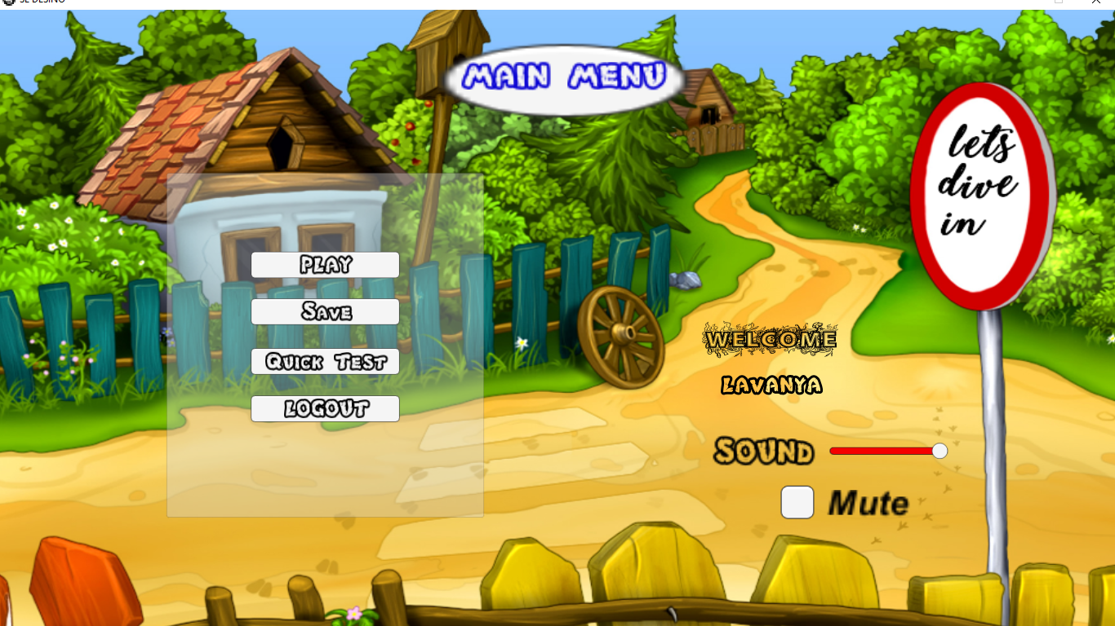

**Modules page**

The below screen shows the different modules that a user can choose any of the option to study their description. The home button can be clicked if the user wants to go to the main menu page.

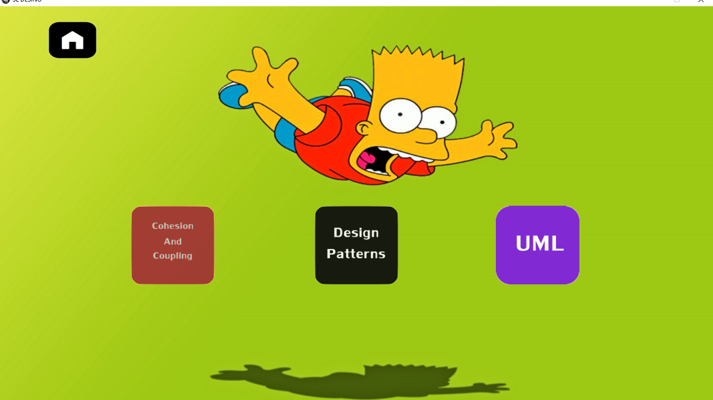

**Select Levels in Modules Page**

The below screen shows the user to select the level for description to study of selected modules in the modules page. The home button helps the user to go to the main menu page. The left arrow button helps the user/ client to go to back page, that is modules page. Here the user/ client can select any level to study.

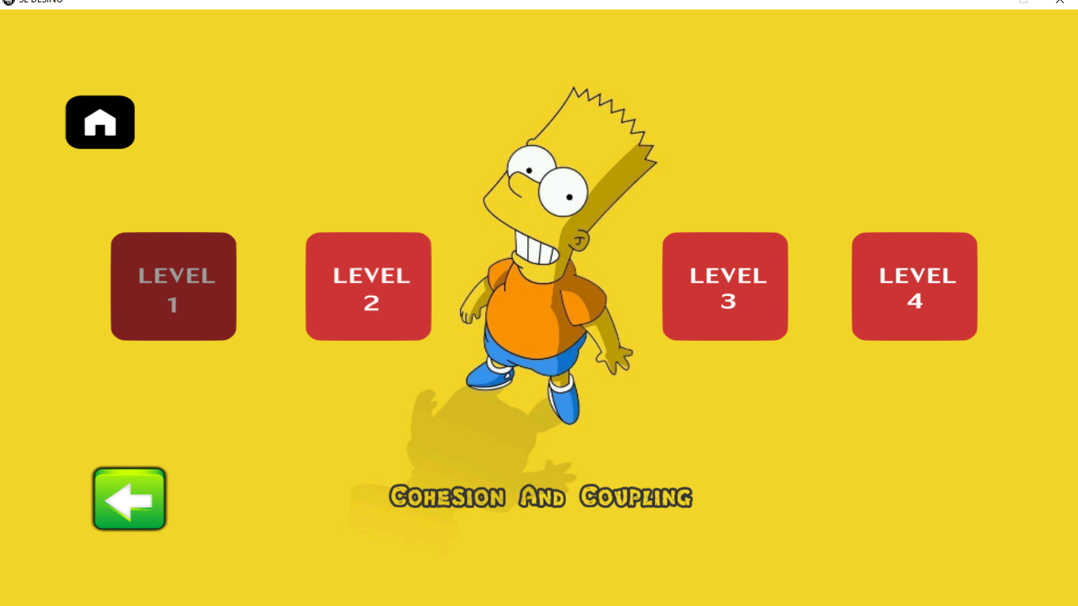

**Level Description**

The below screen shows the user/client showing the selected level to study. The home button helps in getting back the user/ client to go back for menu page. The left arrow button helps in going back to previous page and right arrow helps in going to next page.

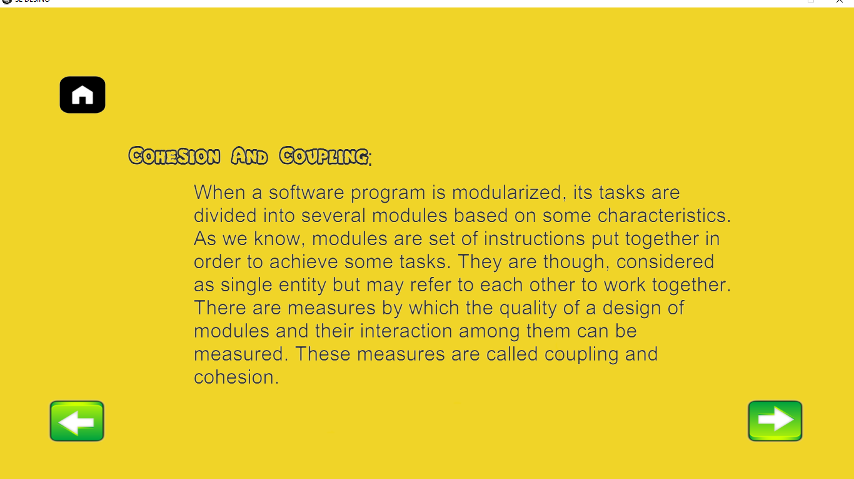

**Puzzle page**

The below page shows the puzzle for the selected level. It is the page that comes when the quict test button is clicked in the main menu page. The user/ client can select any of the 3 levels. The scores below the topics are the maximum scores for the topic. The home button helps the user/client to go to main menu page.

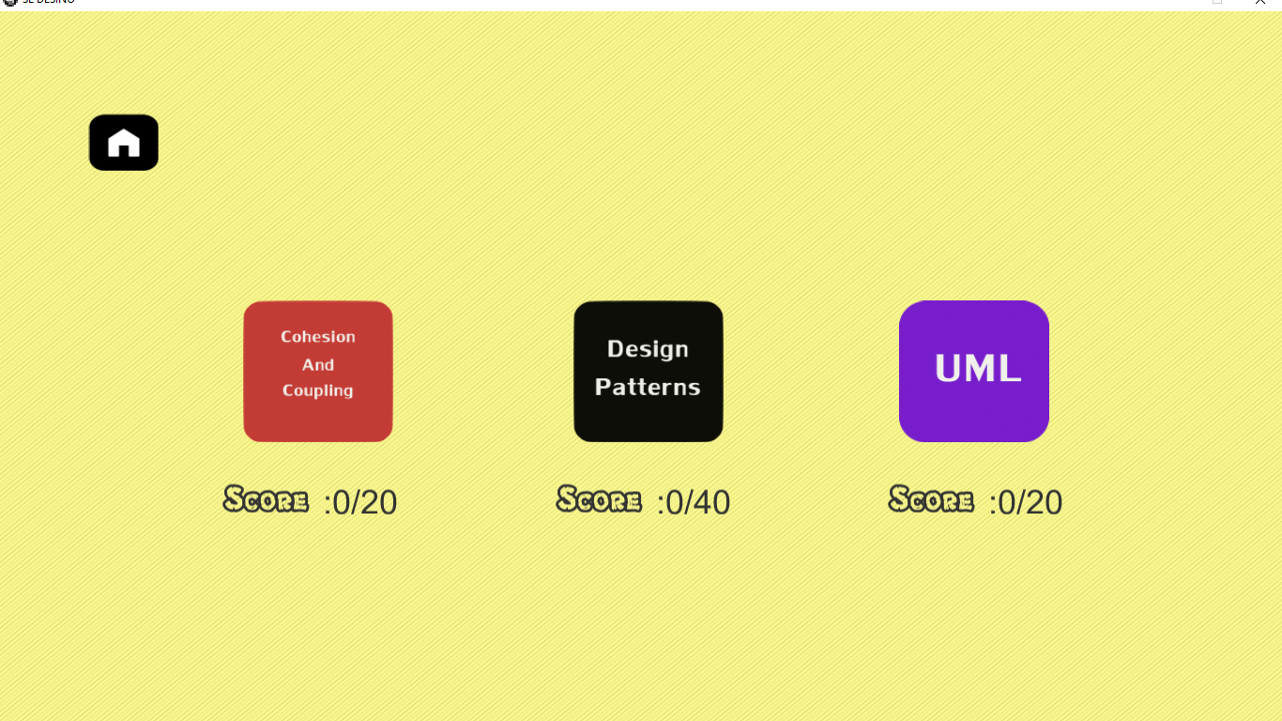

**Questionnaire Page**

The below screen shows the questions that are related to the selected phase. The user/ client can click the option that is correct. The animated avathar jumps if the answer is right. And falls if the answer is wrong. The user/ client has no option to go back and choose the correct option, that is the user/client when clicks the option gets locked and goes to the next question.

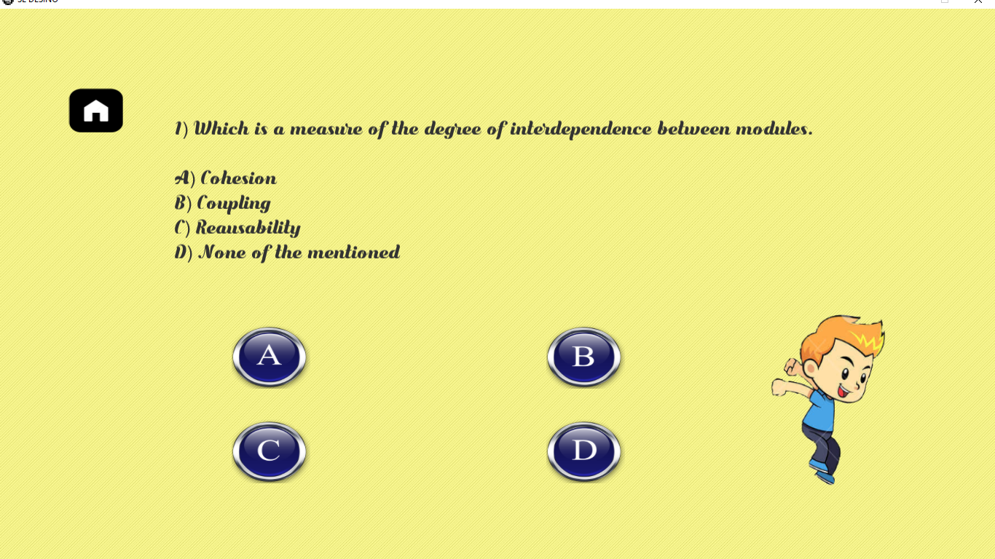

**Round Over Page:**

The below screen displays the score when the user/ client clicks the get score button.

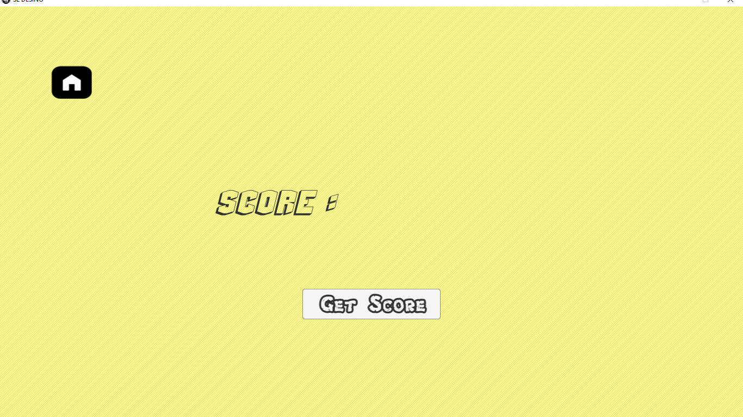

The below screen displays the score that is played by the user/ client. The application displays the comment as per the score. The home button helps the user/ client to go back to main menu page.